pytorch mini-imagenet分类模型训练
fun:
mini-imagenet分类模型训练
env:
numpy==1.19.5 scikit-learn==0.24.2
opencv-python==4.5.1.48 Pillow8.2.0
tensorflow-gpu==1.14.0 Keras==2.2.5
torch==1.4.0 torchvision==0.5.0
ref:
https://blog.csdn.net/heiheiya/article/details/103028543 ResNet-50迁移学习进行图像分类训练
https://blog.csdn.net/u010397980/article/details/86385383 分类及预测示例
https://blog.csdn.net/yinxian9019/article/details/106763892 pytorch gpu
https://blog.csdn.net/qq_33254870/article/details/103362621 ImageFolder
https://blog.csdn.net/qq_39507748/article/details/105394808 ImageFolder
https://blog.csdn.net/weixin_45292794/article/details/108227437 网络参数统计torchsummary
文件：
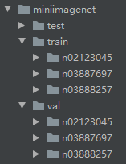
代码：
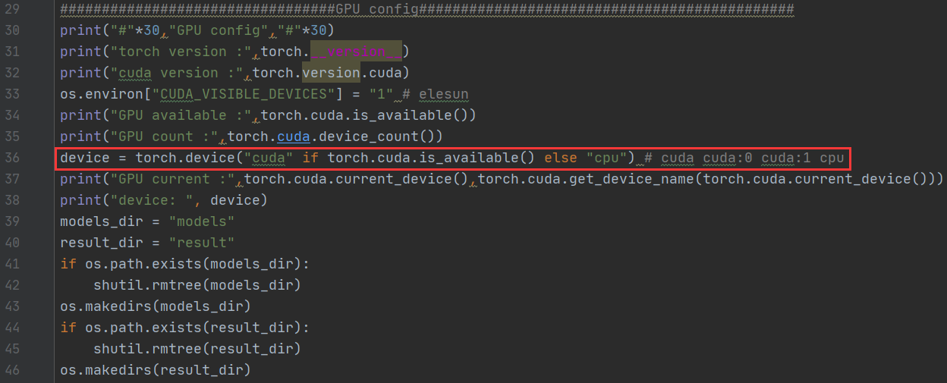
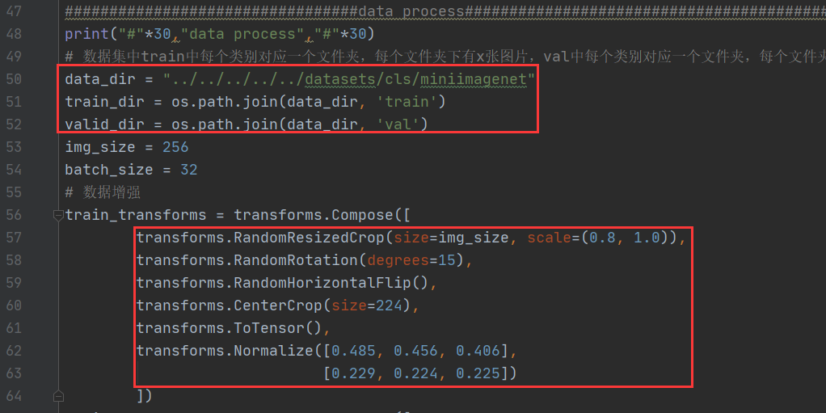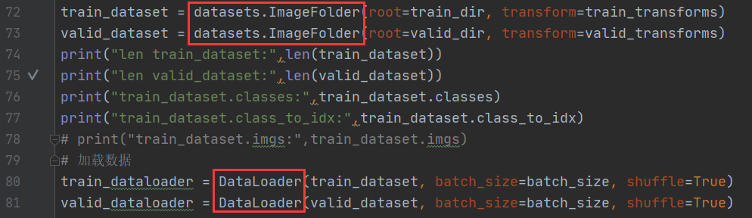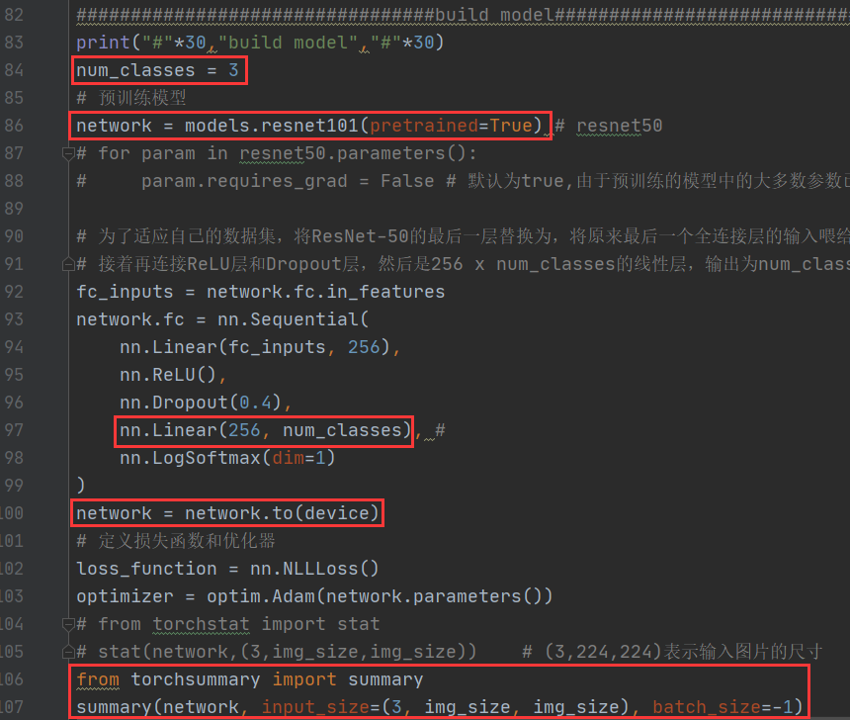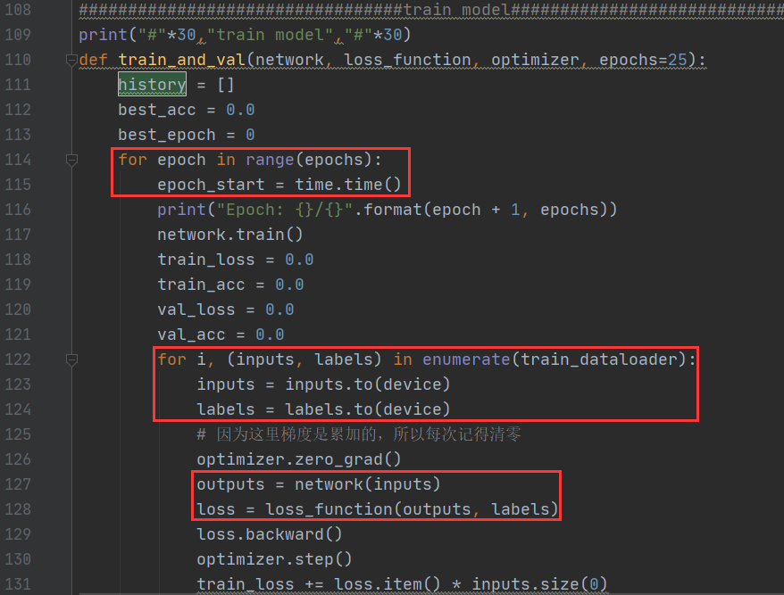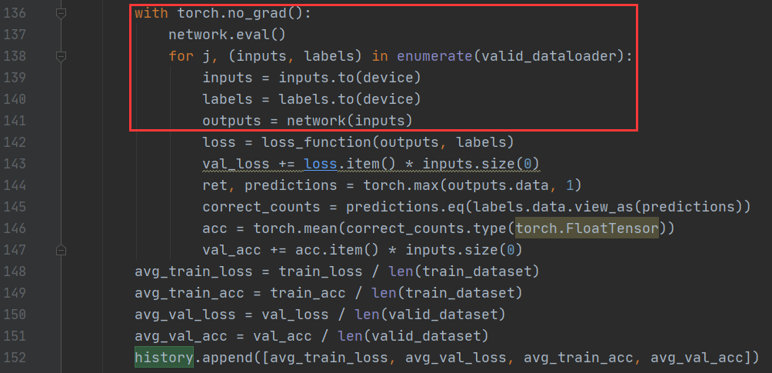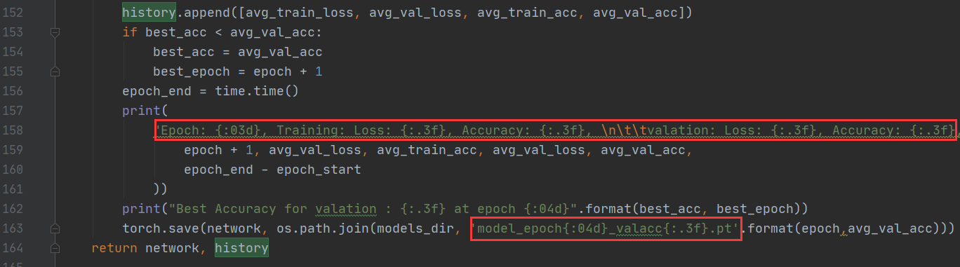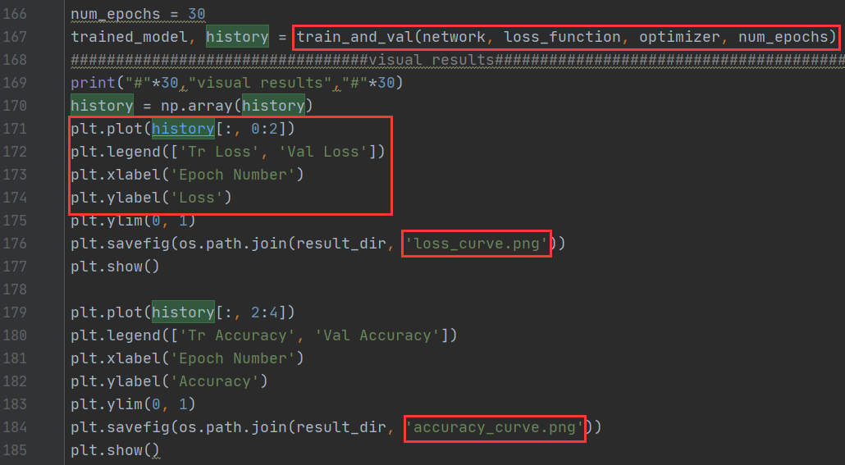

运行：
手动下载预训练模型并拷贝到指定路径
Downloading: "https://download.pytorch.org/models/resnet101-5d3b4d8f.pth" to /root/.cache/torch/checkpoints/resnet101-5d3b4d8f.pth

